AI/ML-based peak and hitfinder project for CXLS/CXFEL

Objective: Use established AI/ML algorithms to find crystal diffraction patterns on the Eiger detector, that is continuously trained on real data and can find peaks/hits taking into account experimental factors (detector distance and X-ray energy) in addition to image data.

Background: Peak and hitfinding is a difficult task in serial crystallography, since it is influenced by experiment specific factors such as X-ray wavelength, sample to detector distance (flashlight analogy) as well as the studied crystal system and protein. The objective of this particular project is therefore to develop an AI/ML-based hitfinder, that can take these parameters into account when separating out real crystal diffraction patterns from noise, salt diffraction (few intense spots), of PEG diffraction (spotty rings).

Goal 1: Train on simulated data with 3 different detector distances, but keeping the X-ray energy and crystal system constant.

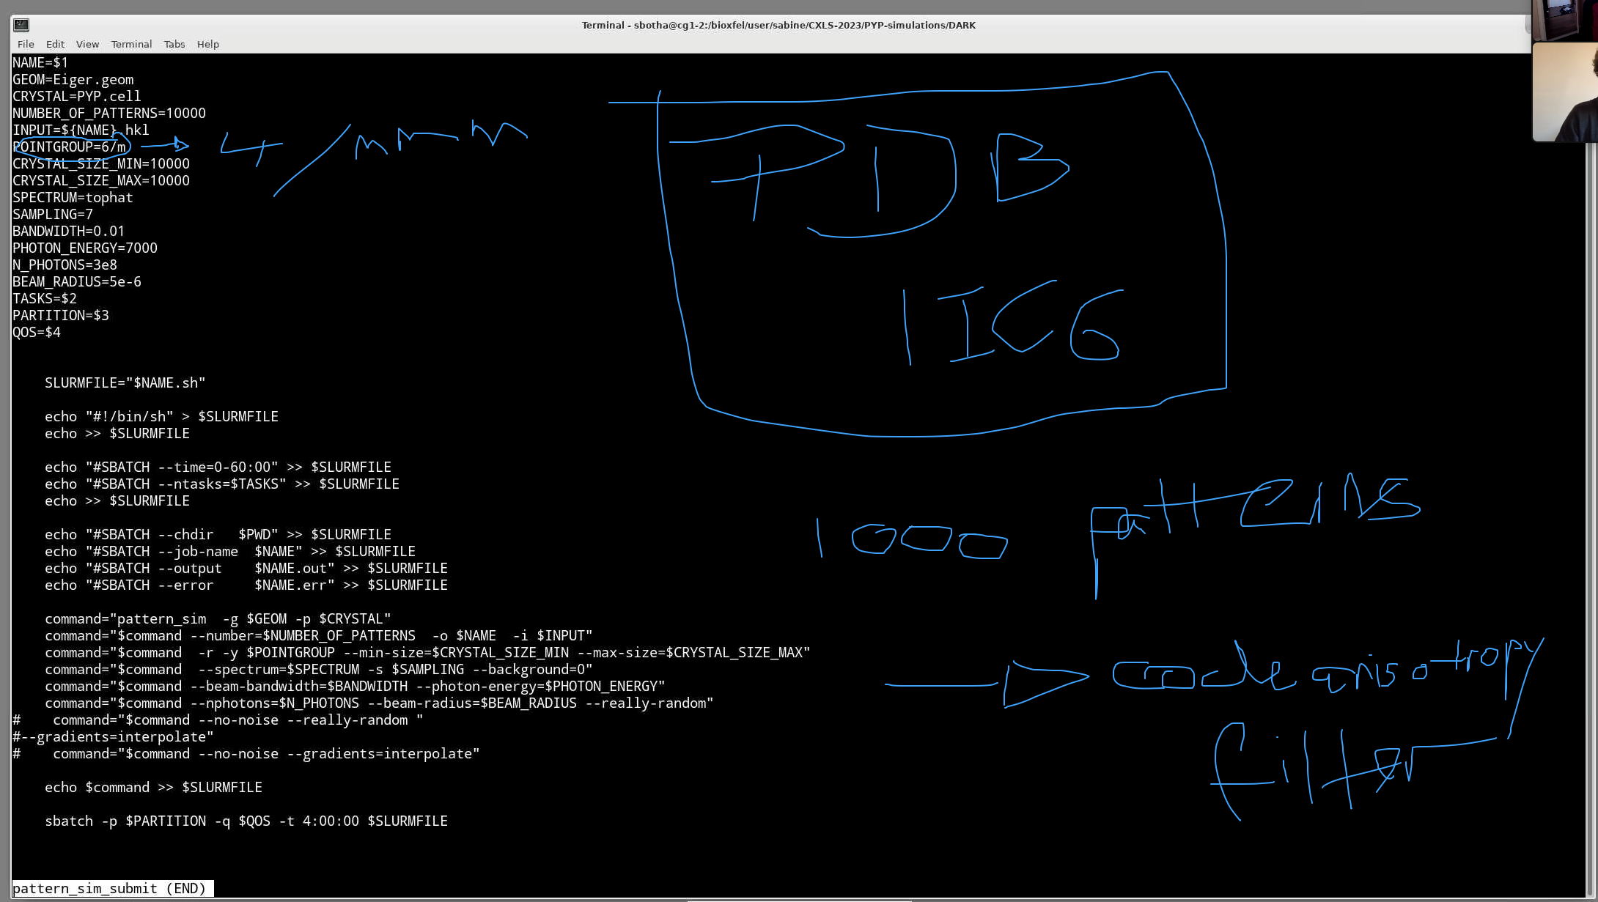
Simulate 10000 patterns with the parameters above.
Protein: Proteinase K, PDB entry 1IC6
Replace “PYP.cell” with the correct unit cell file described in the PDB (roughly tetragonal lattice, unique axis c, constants 67,67,107; 90, 90, 90).
Pointgroup should accordingly be 4/mmm

In pattern_sim_submit

NAME=$1
GEOM=Eiger4M.geom
CRYSTAL=PYP.cell
NUMBER_OF_PATTERNS=10000
INPUT= 1IC6.pdb.hkl
POINTGROUP=4/mmm
CRYSTAL_SIZE_MIN=10000
CRYSTAL_SIZE_MAX=10000
SPECTRUM=tophat
SAMPLING=7
BANDWIDTH=0.01
PHOTON_ENERGY=7000
N_PHOTONS=3e8
BEAM_RADIUS=5e-6
TASKS=$2
PARTITION=$3
QOS=$4

Step 1: Simulate 10000 diffraction patterns of Proteinase K (pdb entry 1ic6) at 7keV on the Eiger detector with detector distances 0.1m, 0.2m, 0.3m; (Other parameters the same as for )

Step 2: Superimpose diffuse water scattering using the same simulation parameters. (e.g. using reborn).

Step3: Train AI/ML hitfinder on simulated data providing both the image data as well as the detector distance as training paramaters. Test the AI/ML hifinder on a newly simulated data with detector distance 0.15m.

Goal 2: Repeat steps 1-3 with 3 different X-ray energies (6.5 keV, 7.5 keV, 8 keV), but keeping the detector distance and crystal system constant (same as for goal 1, with detector distance 0.2m).

Goal 3: Repeat steps 1-3, varying the crystal system. (0.2m, 7keV, pdb entries 1vds, 6yqg and 5hdd).

